**Overview of Computer Networks**

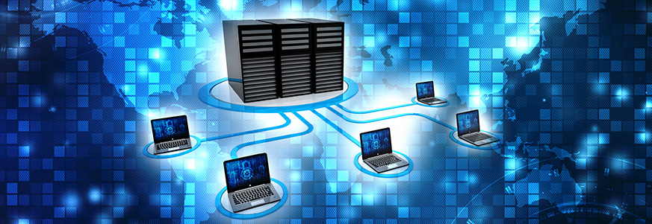

Computer networks are the basis of communication in IT. They are used in a huge variety of ways and can include many different types of network. A computer network is a set of computers that are connected together so that they can share information.

A computer network is a system in which multiple computers are connected to each other to share information and resources.

**Characteristics of a Computer Network**

* Share resources from one computer to another.
* Create files and store them in one computer, access those files from the other computer(s) connected over the network.
* Connect a printer, scanner, or a fax machine to one computer within the network and let other computers of the network use the machines available over the network.

**Following is the list of hardware's required to set up a computer network.**

* Network Cables
* Distributors
* Routers
* Internal Network Cards
* External Network Cards

**Network Cables**

Network cables are used to connect computers. The most commonly used cable is Category 5 cable RJ-45.

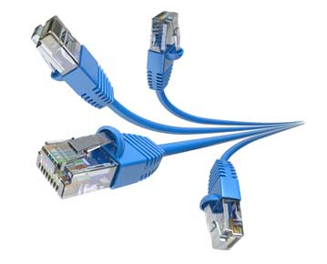

**Distributors**

A computer can be connected to another one via a serial port but if we need to connect many computers to produce a network, this serial connection will not work.

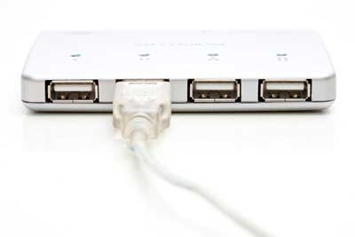

The solution is to use a central body to which other computers, printers, scanners, etc. can be connected and then this body will manage or distribute network traffic.

**Router**

A router is a type of device which acts as the central point among computers and other devices that are a part of the network. It is equipped with holes called ports. Computers and other devices are connected to a router using network cables. Now-a-days router comes in wireless modes using which computers can be connected without any physical cable.

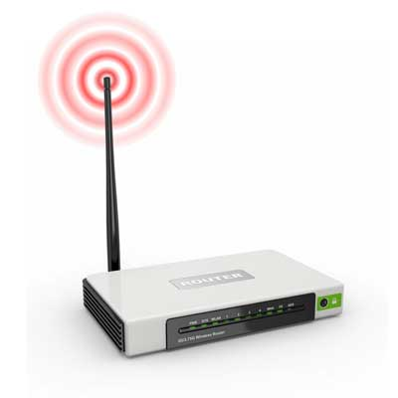

**Network Card**

Network card is a necessary component of a computer without which a computer cannot be connected over a network. It is also known as the network adapter or Network Interface Card (NIC). Most branded computers have network card pre-installed. Network cards are of two types: Internal and External Network Cards.

**Internal Network Cards**

Motherboard has a slot for internal network card where it is to be inserted. Internal network cards are of two types in which the first type uses Peripheral Component Interconnect (PCI) connection, while the second type uses Industry Standard Architecture (ISA). Network cables are required to provide network access.

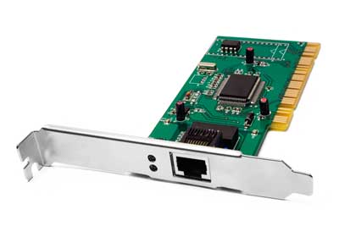

**External Network Cards**

External network cards are of two types: Wireless and USB based. Wireless network card needs to be inserted into the motherboard, however no network cable is required to connect to the network.

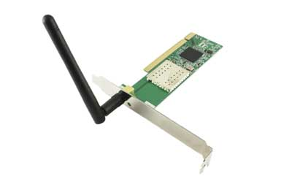

**Universal Serial Bus (USB)**

USB card is easy to use and connects via USB port. Computers automatically detect USB card and can install the drivers required to support the USB network card automatically.

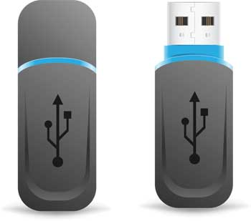

**What is Computer Network?**

A computer network is a set of devices connected through links. A node can be computer, printer, or any other device capable of sending or receiving the data. The links connecting the nodes are known as communication channels.

Computer Network uses distributed processing in which task is divided among several computers. Instead, a single computer handles an entire task, each separate computer handles a subset.

**Following are the advantages of Distributed processing:**

**Security**: It provides limited interaction that a user can have with the entire system. For example, a bank allows the users to access their own accounts through an ATM without allowing them to access the bank's entire database.

**Faster problem solving**: Multiple computers can solve the problem faster than a single machine working alone.

**Security through redundancy**: Multiple computers running the same program at the same time can provide the security through redundancy. For example, if four computers run the same program and any computer has a hardware error, then other computers can override it.

**What is a Computer Network?**

Computer Network is a group of computers connected with each other through wires, optical fibres or optical links so that various devices can interact with each other through a network.

The aim of the computer network is the sharing of resources among various devices.

In the case of computer network technology, there are several types of networks that vary from simple to complex level.

**Components of Computer Network:**

